ISO 9001 IQNet CERTIFIED

References
Powerstar System Development and Main Contractor Ltd.
H-1039 Budapest, Nagyvárad u. 11-17.
Tel: (36-1)-2400-350, (36-1)-2400-352 Fax: (36-1) 2400-349
Home-page: www.powerstar.hu E-mail: office@powerstar.hu




Mobile Solar System 1500W with 32pcs. of solar modules (Líbya)

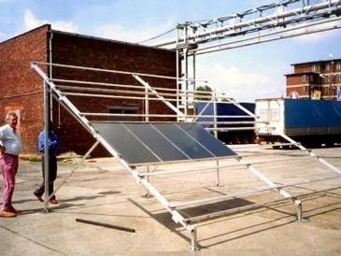

Solar System 1500W with 32pcs. of solar modules (Croatia)

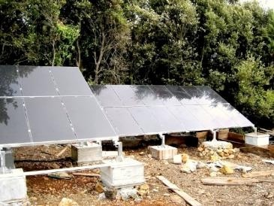

Solar System 3500W with 64 pcs. of solar modules

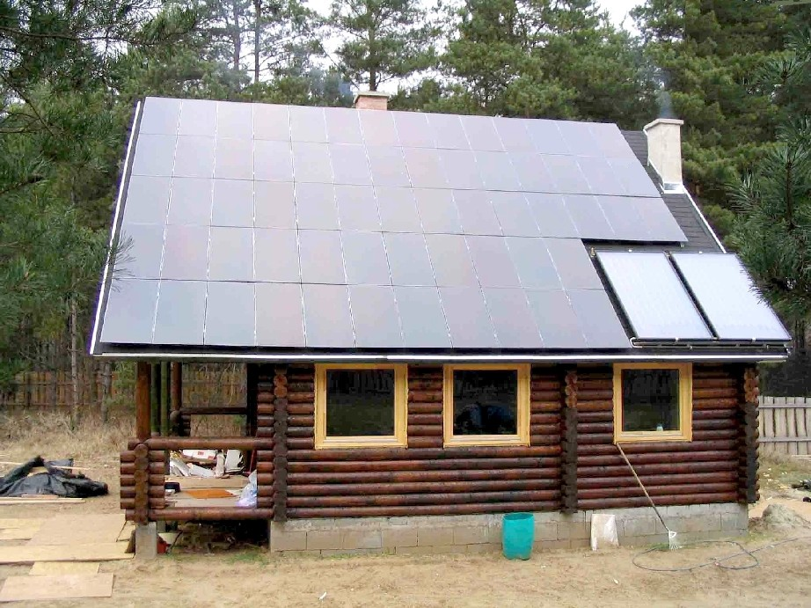

Solar System 3500W with 64 pcs. of solar modules
(Monorierdő)

Powerstar PSCN-48V/1500 complete solar system

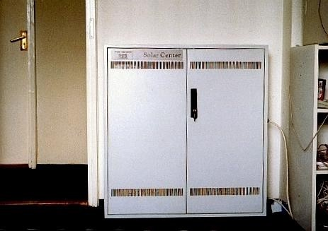

Solar System 1500W with 64 pcs. of solar modules (Obuda Island)

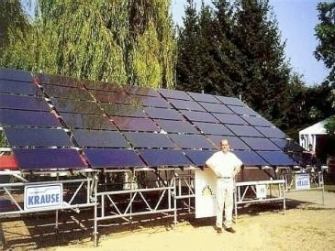

Powerstar PSC-48V/3500 complete photovoltaic solar system 48V, 200Ah built-in batteries

